A non-clinical study of 10 pharmaceutical products was conducted in mice over a 45 day period with 51% of the mice being male. All drug regimens used between 161 – 230 mice per drug study. Summary statistics across all drug regimens can be found in Figure 1.

There is a strong relationship between tumor size and weight of the mouse as indicated with a correlation coefficient value of 0.84. The linear equation is expressed by a best fit line y = 0.74(x) – 10.15.

Capomulin, the drug regimen of principle interest, was proven to be effective at reducing tumor size. As an example, in Mouse ID m957, tumor volume was reduced from 45 mm3 to 33.3 mm3 ( a 26% decrease).

In 4 drugs of interest, Capomulin, Ramicane, Infubinol, and Ceftamin, the median final tumor size was lowest for Ramicane (36.56 mm3), compared to Capomulin (38.13 mm3), Infubinol (60.17 mm3), and Ceftamin (59.85 mm3). This suggests that Ramicane could be a more effective treatment of tumors than the other 3 regimens. A boxplot of each of these regimens can be found in Figure 2.

An analysis of Capomulin, Ramicane, Infubinol, and Ceftamin (see Figure 3) showed that Capomulin and Ramicane were effective at reducing tumor size. Ceftamin showed promise for significantly limiting tumor growth. Infubinol proved ineffective at both reducing tumor size and at inhibiting tumor growth. Ramicane had the highest median tumor reduction of these 4 drug regimens.

Figure 1: Summary Statistics Across all 10 Drug Regimens of the Study

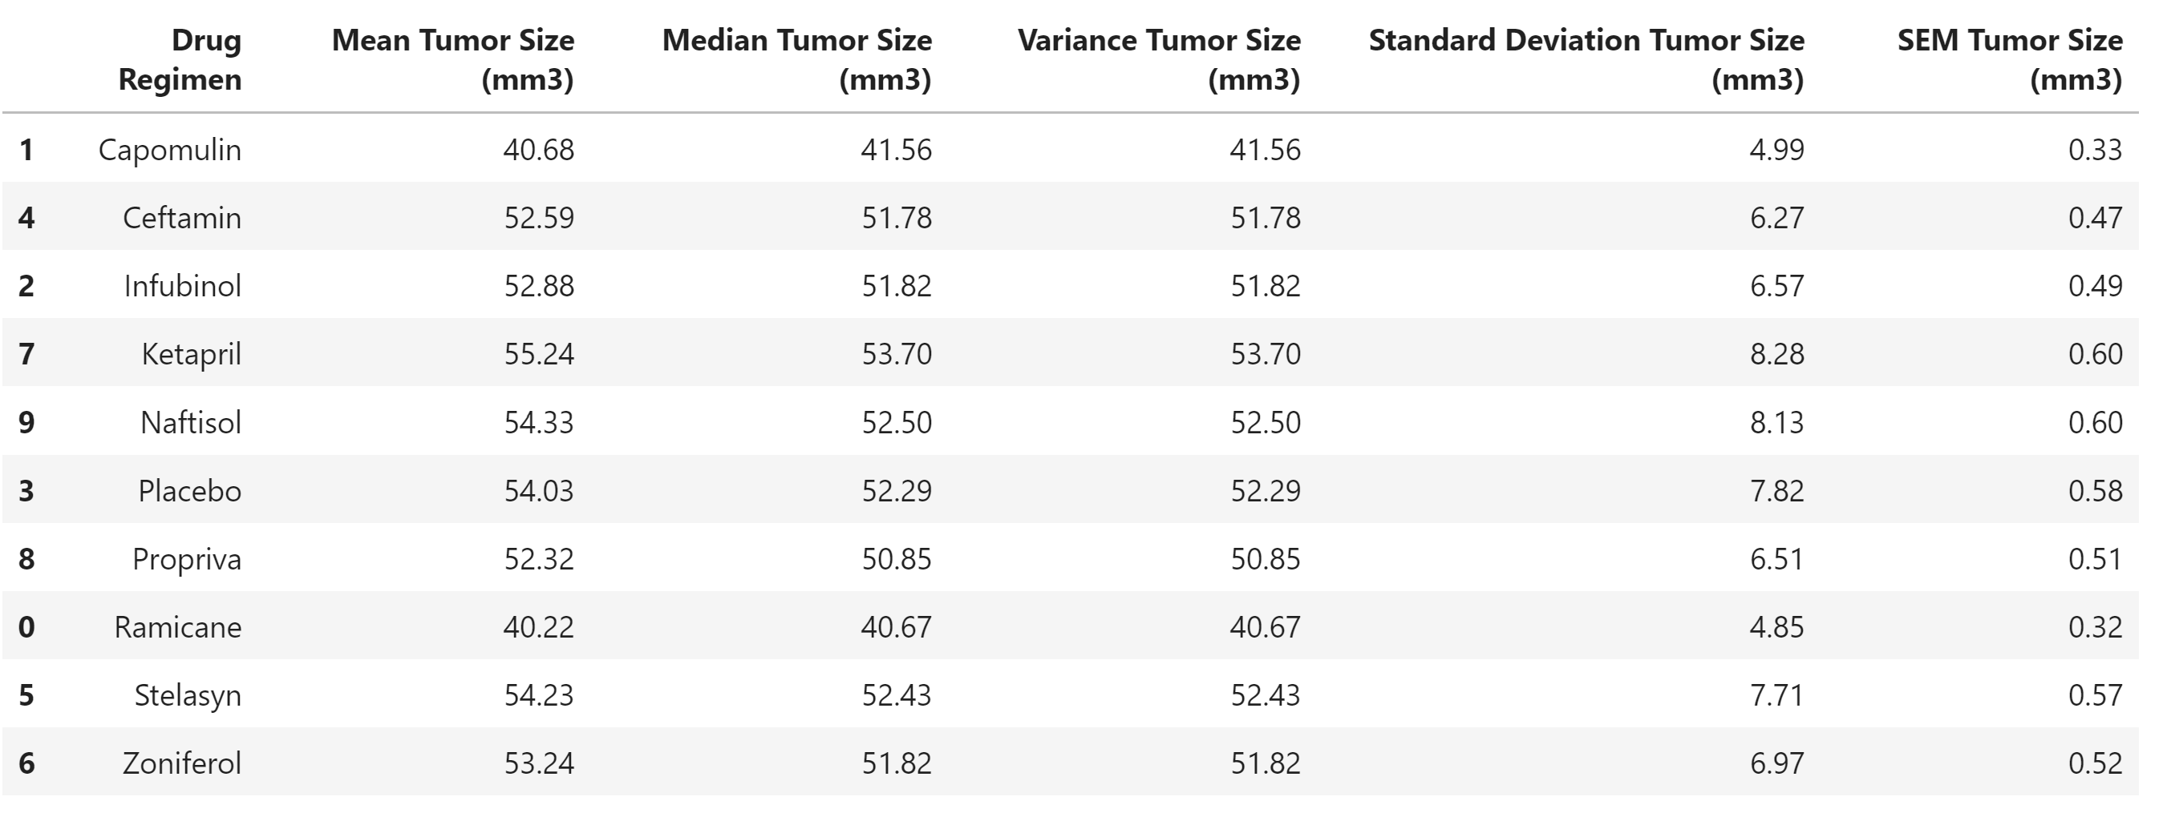

Figure 2: Boxplot of Final Tumor Size (mm3) for Capomulin, Ramicane, Infubinol, and Ceftamin

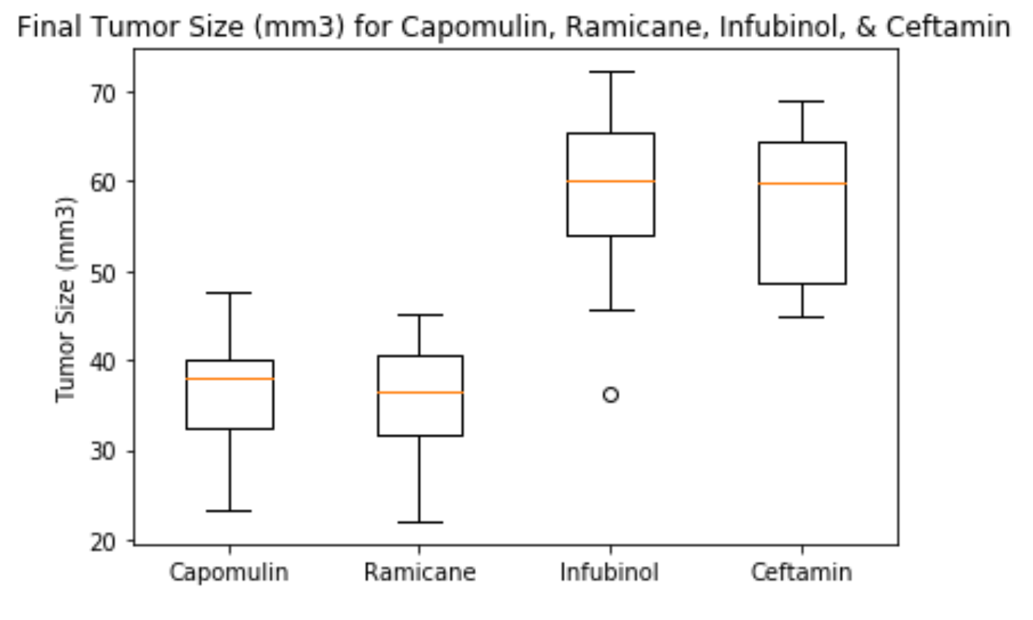

Figure 3: Reduction of Tumor Sizes (mm3) for Capomulin, Ramicane, Infubinol, and Ceftamin

